Day-16(9/7/2025)
Emp ID : 110714877
NAME :Kinnera venkatamma

Write algorithm/steps for selection sort ?

Selection Sort Algorithm
Start with the first element of the array.
Repeat the following steps for each position in the array (from the first to the second-to-last element):
Assume the current position is the minimum.
Compare the current element with all the elements to its right.
If a smaller element is found, update the minimum to that element's position.
Swap the element at the current position with the element at the minimum position.
Continue until the entire array is sorted.
End.
Task2. Write a pseudo code for the selection sort

FUNCTION selectionSort(array arr)
n = length of arr

FOR i FROM 0 TO n - 2
// Assume the current position 'i' holds the minimum element
minIndex = i

// Find the index of the minimum element in the unsorted part of the array
FOR j FROM i + 1 TO n - 1
IF arr[j] < arr[minIndex] THEN
minIndex = j
END IF
END FOR

// Swap the found minimum element with the element at the current position 'i'
// This places the minimum element in its correct sorted position
temp = arr[minIndex]
arr[minIndex] = arr[i]
arr[i] = temp
END FOR

END FUNCTION

Task3. Wap to make sure your list is sorted using selection sort.

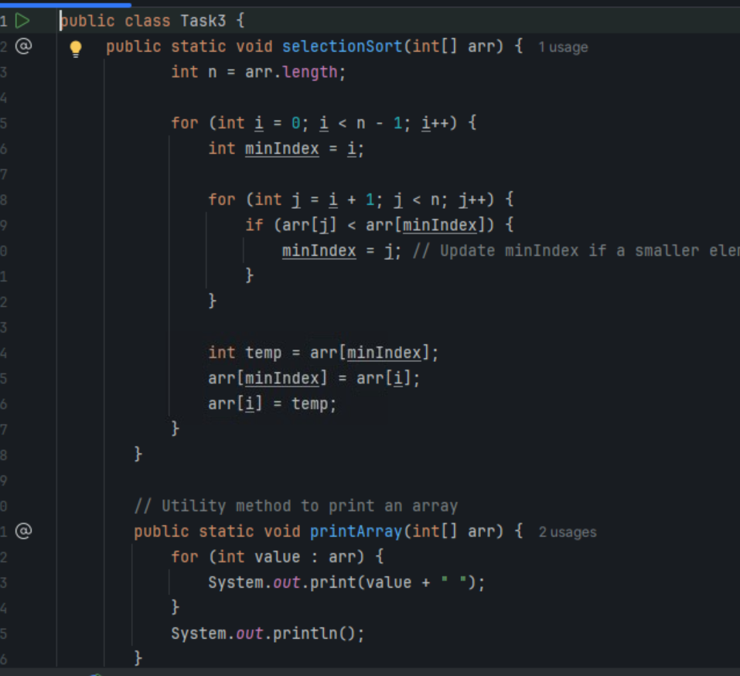
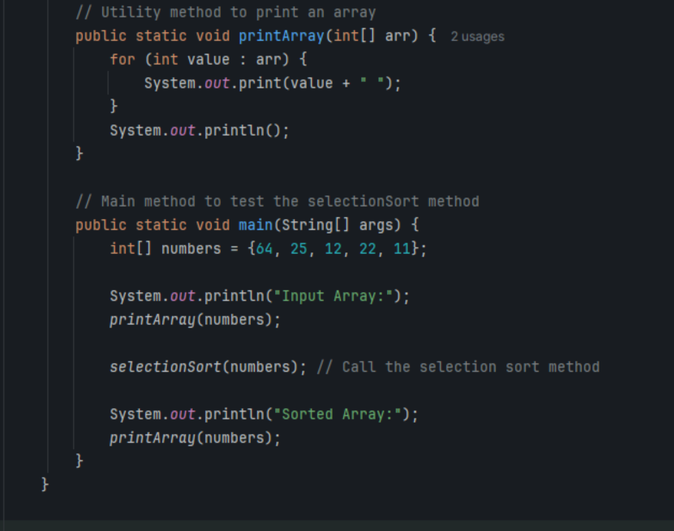

Task 4: Write algorithm for the Bubble sort.

Bubble Sort is the simplest sorting algorithm that works by repeatedly swapping the adjacent elements if they are in the wrong order.
This algorithm is not suitable for large data sets as its average and worst-case time complexity are quite high.

We sort the array using multiple passes. After the first pass, the maximum element goes to end (its correct position).
Same way, after second pass, the second largest element goes to second last position and so on.
In every pass, we process only those elements that have already not moved to correct position. After k passes, the largest k elements must have been moved to the last k positions.
In a pass, we consider remaining elements and compare all adjacent and swap if larger element is before a smaller element.
If we keep doing this, we get the largest (among the remaining elements) at its correct position.

[5,6,1,3] - [5,6,1,3] –[5,1,6,3]- [5,1,3,6] –
[1,5,3,6] – [1,3,5,6]

Task 5: Write pseudo code for the bubble sort

FUNCTION bubbleSort(array A)
n = length of A

FOR i FROM 0 TO n - 2
// Inner loop for comparisons and swaps
FOR j FROM 0 TO n - i - 2
// Compare adjacent elements
IF A[j] > A[j+1] THEN
// Swap elements if they are in the wrong order
temp = A[j]
A[j] = A[j+1]
A[j+1] = temp
END IF
END FOR
END FOR

RETURN A
END FUNCTION

Task 6: Wap to make sure your list is sorted using Bubble sort.

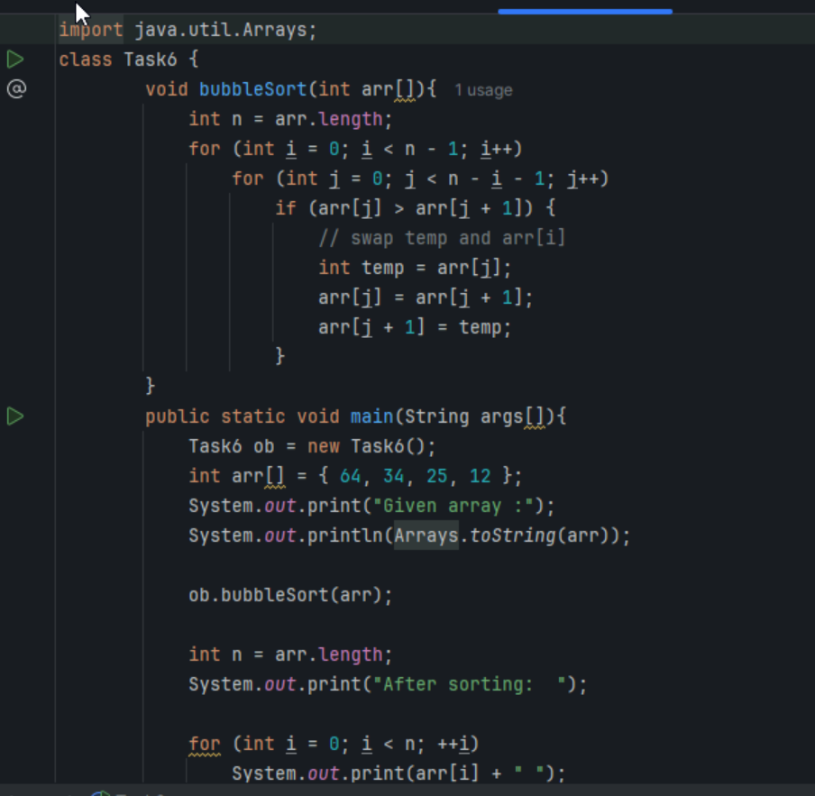

Task7 . Write algorithm for the Insertion sort.

The algorithm of Insertion Sort is mentioned below:

Variable declared i=1
Traverse the Array till i<N
If arr[i]<arr[i-1] then arr[j]=value present after shifting the elements of the array from j to i-1.
Return the Sorted Array.

Task 8: Write pseudo code for the Insertion sort

PROCEDURE insertionSort(array arr, INTEGER n)
FOR i FROM 1 TO n - 1 DO
SET key = arr[i]
SET j = i - 1

WHILE j >= 0 AND arr[j] > key DO
SET arr[j + 1] = arr[j]
DECREMENT j
END WHILE

SET arr[j + 1] = key
END FOR
END PROCEDURE

Task 9: Wap to make sure your list is sorted using Insertion sort.

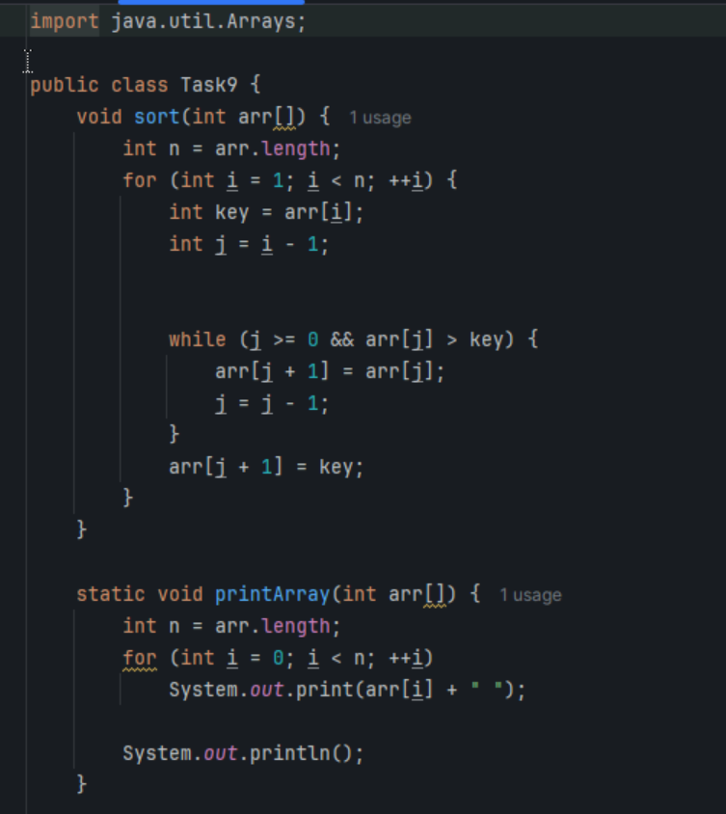
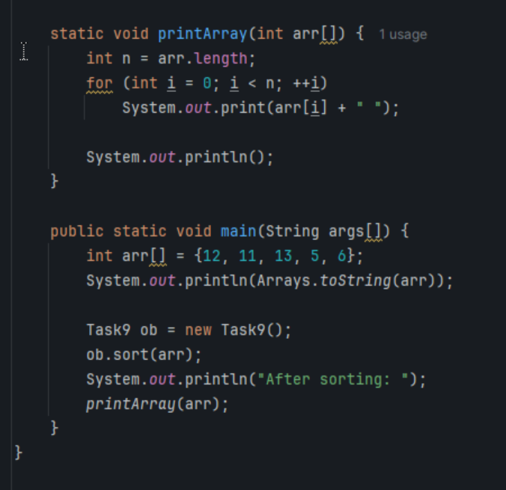

Task 10: What are the advantages and disadvantages of Bubble sort Algo?List them

Advantages:

Simple to understand and implement
Few lines of code
In-place sorting
Adaptive nature

Disadvantages:

Inefficient for large datasets
Many element swaps
Not optimal for most real-world scenarios
Wastes time when no swaps are needed

Task 11: Algorithm for merge sort ?

The Merge Sort algorithm can be described like this:

Divide the unsorted array into two sub-arrays, half the size of the original.
Continue to divide the sub-arrays as long as the current piece of the array has more than one element.
Merge two sub-arrays together by always putting the lowest value first.
Keep merging until there are no sub-arrays left.

Task 12 pseudo code for merge sort,

FUNCTION mergeSort(array, low, high)
IF low < high THEN
mid = low + (high - low) / 2 // Calculate middle index
mergeSort(array, low, mid) // Recursively sort the left half
mergeSort(array, mid + 1, high) // Recursively sort the right half
merge(array, low, mid, high) // Merge the sorted halves
END IF
END FUNCTION

FUNCTION merge(array, low, mid, high)
DECLARE n1 = mid - low + 1
DECLARE n2 = high - mid

CREATE temporaryLeftArray[n1]
CREATE temporaryRightArray[n2]

// Copy data to temporary arrays
FOR i FROM 0 TO n1 - 1 DO
temporaryLeftArray[i] = array[low + i]
END FOR
FOR j FROM 0 TO n2 - 1 DO
temporaryRightArray[j] = array[mid + 1 + j]
END FOR

DECLARE i = 0 // Initial index of first subarray
DECLARE j = 0 // Initial index of second subarray
DECLARE k = low // Initial index of merged subarray

// Merge the temporary arrays back into the original array
WHILE i < n1 AND j < n2 DO
IF temporaryLeftArray[i] <= temporaryRightArray[j] THEN
array[k] = temporaryLeftArray[i]
i = i + 1
ELSE
array[k] = temporaryRightArray[j]
j = j + 1
END IF
k = k + 1
END WHILE

// Copy remaining elements of temporaryLeftArray, if any
WHILE i < n1 DO
array[k] = temporaryLeftArray[i]
i = i + 1
k = k + 1
END WHILE

// Copy remaining elements of temporaryRightArray, if any
WHILE j < n2 DO
array[k] = temporaryRightArray[j]
j = j + 1
k = k + 1
END WHILE
END FUNCTION

TSK 13 .code for Merge sort

Task 14: Algorithm for quick sort

1. Choose the highest index value has pivot
2. Take two variables to point left and right of the list
excluding pivot
3. Left points to the low index
4. Right points to the high
5. While value at left is less than pivot move right
6. While value at right is greater than pivot move left
7. If both step 5 and step 6 does not match swap left and right
8. If left ≥ right, the point where they met is new pivot

Task 15: Pseudo code for quick sort

function partitionFunc(left, right, pivot)
leftPointer = left
rightPointer = right - 1

while True do
while A[++leftPointer] < pivot do
//do-nothing
end while

while rightPointer > 0 && A[--rightPointer] > pivot do
//do-nothing
end while

if leftPointer >= rightPointer
break
else
swap leftPointer,rightPointer
end if
end while

swap leftPointer,right
return leftPointer
end function

Task 16: Code for Quick sort

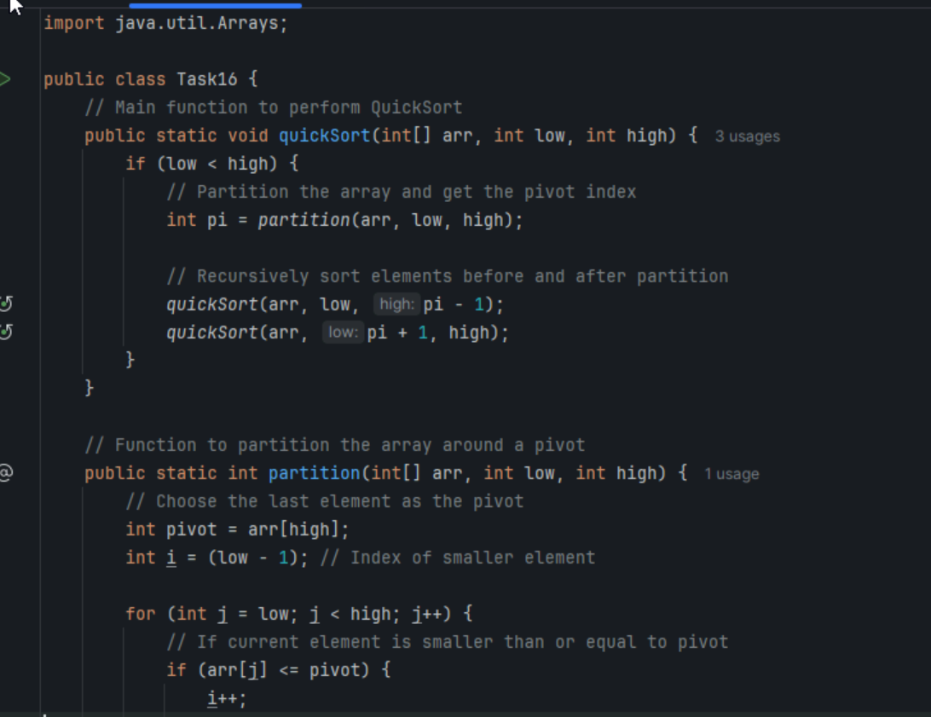

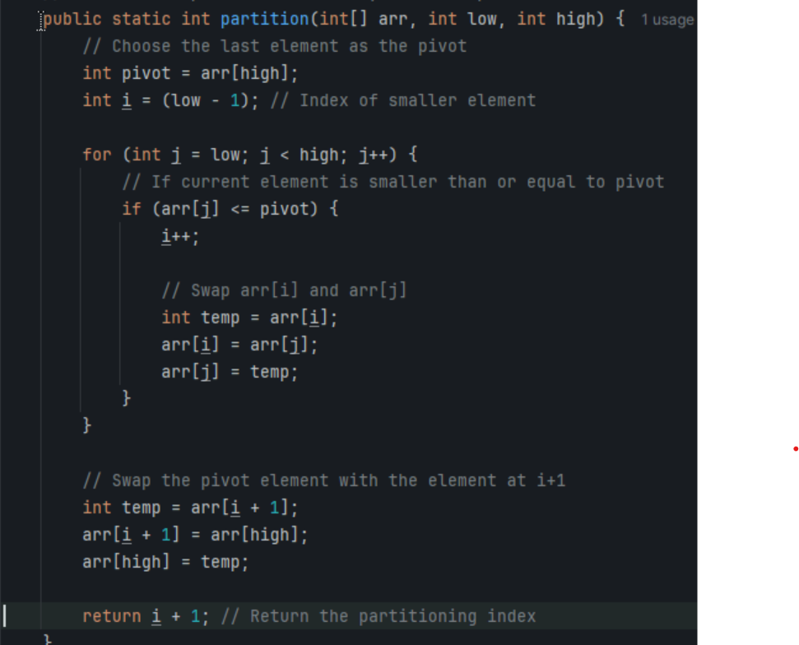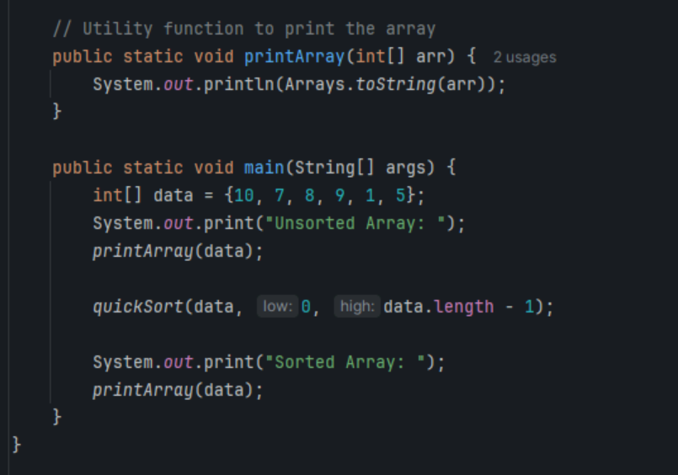

Task 17: Which one is better merge or bubble in terms of time complexity

Note:
Merge : O(n log n )
Bubble: O (n square).

Merge Sort has a better time complexity than Bubble Sort.
Merge Sort has a time complexity of O(n log n), while Bubble Sort has a time complexity of O(n^2).
This means that for larger datasets, Merge Sort will generally perform significantly faster than Bubble Sort.

Task 18: Leet code qn:

Find the time complexity of the given merge operation between two sorted array.

Note: O(n + m) as we traverse both arrays once, n and m are size of both the arrays

https://leetcode.com/problems/merge-sorted-array/description/

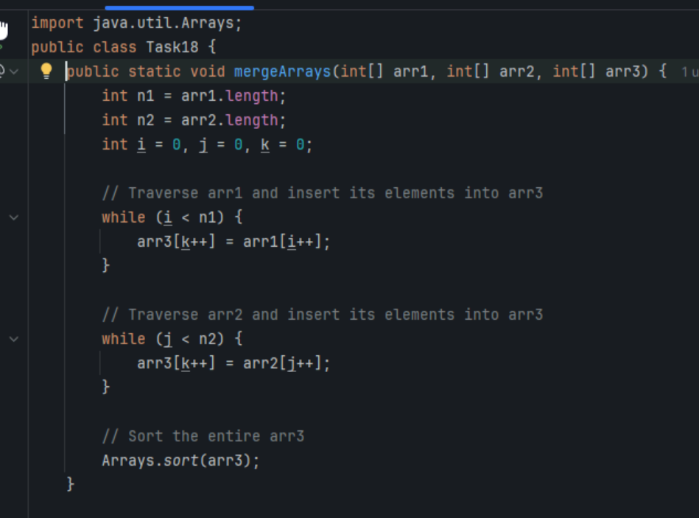
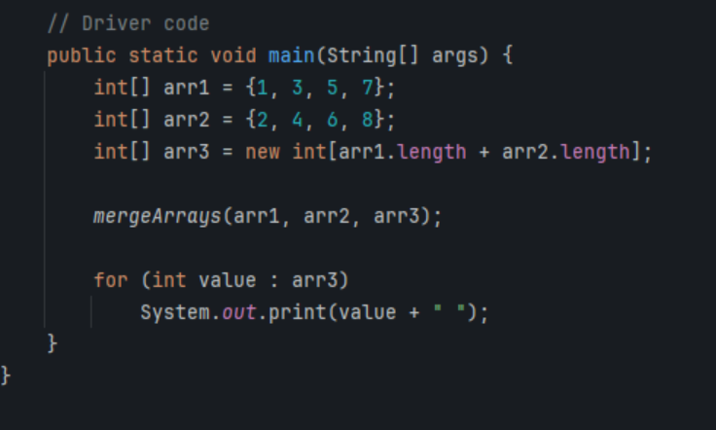

Task 19:

This code is going overflow of stack.. Can you plz help me fix it guys.. ☹️

Plz be careful: Because recursive calls consume stack memory for every invocation and excessive depth can exceed system limits also..

public class RecLoop {

public int calc(int n) {
if (n == 0) return 0;
return n + calc(n);
}

psvm(String[] args) {
System.out.println(new RecLoop().calc(10));
}
}

HERE, we need to decrease n value otherwise it goes to infinite loops -
return n + calc(n-1);
Task 20:

public class BinarySearchNew {
public int search(int[] arr, int toFind) {
int left = 0, right = arr.len - 1;

while (left <= right) {
int mid = left + (right - left) / 2;

if (arr[mid] == toFind) {
return mid;
} else if (arr[mid] < toFind) {
left = mid + 1;
} else {
right = mid - 1;
}
}
return -1;
}
}

binary search function can we use in unsorted list?

Unlike linear search, binary search can be used for efficient approximate matching. There are operations such as finding the smallest and largest element that can be done efficiently on a sorted array but not on an unsorted array.

Will it give you correct index no?

Binary search is most effective when applied to sorted data, with a time complexity of O(log n). However, its efficiency drastically decreases when used on unsorted data, resulting in a time complexity of O(n). In such cases, the advantages of binary search are lost.

